CCI ASSIGNMENT – 3  **Name:** RAHUL VARMA

**Roll No:** S20200010212

Question: Predict the future climate/geographical suitability of Potato in India using the Max-Ent model.

Data:

**Climate Model**: MPI-ESM1-2-HR

**RCP**: 4.5

**Year**: 2090

**Resolution**: 10 mins

For this assignment, I have downloaded MPI-ESM1-2-HR model for RCP 4.5 with 10 mins spatial resolution for global climate model (GCM) from the world clim website.

Link: <https://www.worldclim.org/data/cmip6/cmip6_clim10m.html#2081-2100>

Maxent Model:

An open-source website where you can download maxent software for modelling species niches and distributions using a machine-learning technique called maximum entropy modelling. The model expresses a probability distribution based on a set of environmental grids and georeferenced occurrence sites, with each grid cell predicting the species' appropriateness of conditions. Based on assumptions about the input data and biological sampling efforts that resulted in occurrence records, the result can be regarded as predicted probability of presence or predicted local abundance.

The software’s used in predicting the climate suitability of a potato crop in this assign are as follows:

1) QGIS

2) R-STUDIO

3) Java JDK

4) Max-Ent MODEL

Process and steps followed:

* Grab the data of 2090 from world clim website.
* Choosing the Model MPI-ESM1-2-HR data for 10 min resolution and RCP – 4.5.
* Download the data for tn, tx and pr parameters.
* Use the QGIS software for analyzing and processing the data.
* The Future data is in multi band so we need to convert it into single band.
* Now we must convert the multi band data of World clim to single band data using the R-studio:

1. install Package("raster") .

and use the given R code in assignment 2 and convert the data from multi band to single band.

We get these three files **(.tif to .asc)**.

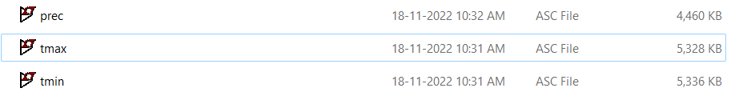

* Go to QGIS software and open .asc files in QGIS and go to layer and add a vector layer which directs towards .shp file for India (shape file for India).
* The data we downloaded is for world so, we should mask the data for only India.
* Now we should **mask the data for India**.
* In raster section create a new masked layer with input as .asc file and crop data as the .shp file and save into a new file. Do the same for other .asc files.

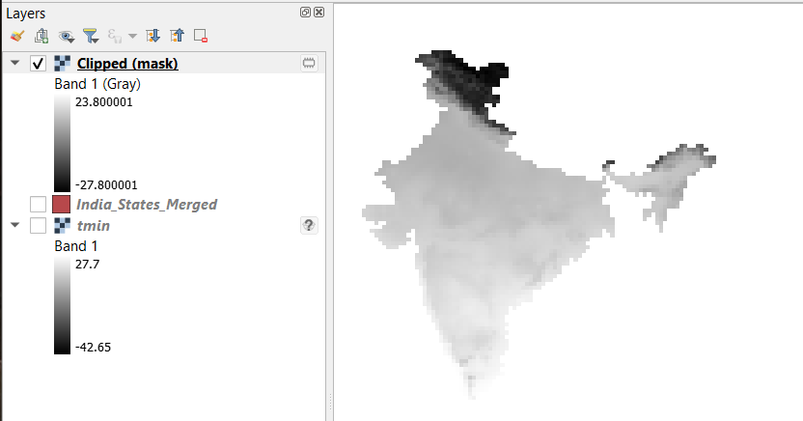 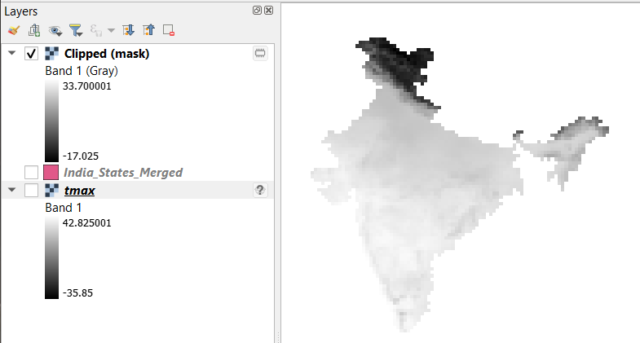

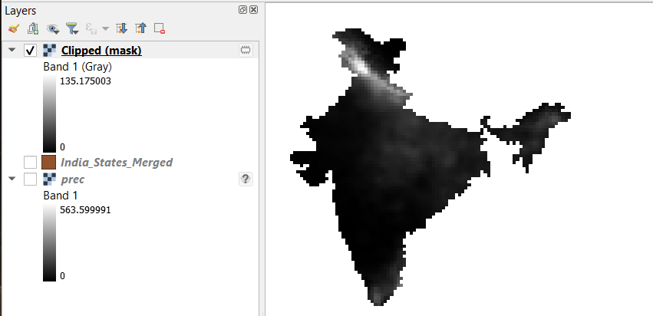

The new .asc file’s which are masked for only India are:

The size is reduced (since we selected only India).

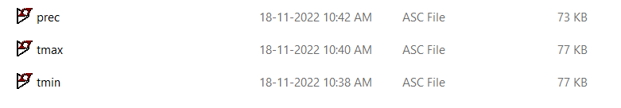

Maxent Model:

Now, Run the maxent Executable Jar File:

* Select the data for potato given in the assignment (Potato_Maxent.csv) in the Samples section.
* In the Environmental Layers select the three .asc file’s which we masked for India.
* And save in some folder.

And Run.

The Output will be created and saved in the selected folder there we can find the plot.

The Final Output:

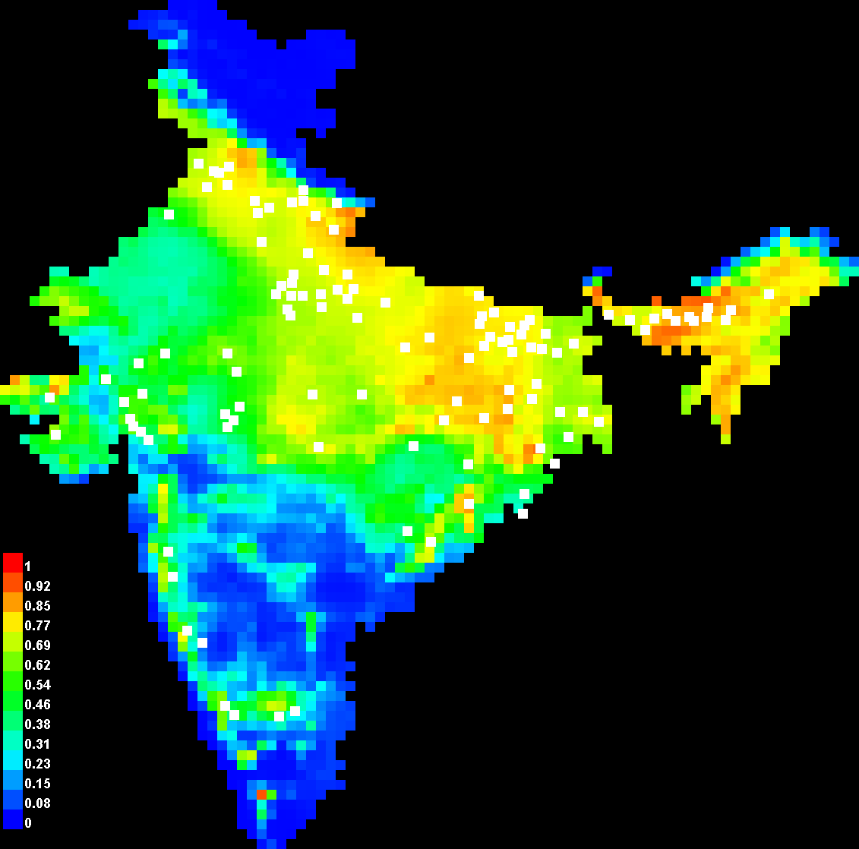

In the figure, the white square boxes show the longitude and latitude points of the rice crop which was included in the maxent model in csv form.

* **Climatic Essential for Potato:**

The potato is a temperate climate crop that grows in a wide range of climatic conditions. It is only grown in conditions where the temperature is moderately cool during the growing seasons. The vegetative growth of the plant is best at 24°C, while tuber development is best at 20°C. As a result, potato is grown in the hills during the summer and in the tropical and subtropical regions during the winter. The crop can be raised to a height of 3000 m above sea level.

* **History of Potato in India:**

After rice, wheat, and maize, potatoes are the fourth most important crop in the world and the top non-grain crop. How could an Andean tuber convince the world to adopt it so fully in just a few centuries? The potato's unrivalled nutritional value, relative ease of cultivation compared to some major cereals, ability to easily navigate wars and tax censuses due to its talent for hiding underground from collectors, and especially its camaraderie with laboures in the fields were all factors that contributed to its appeal.

**Conclusion:**

* From the above plot we can say that the red colour region has a high source of potato

crop in the future 2090s, the green colour region has a moderate source of potato crop in the future, while the blue colour region has low source of potato crop in the future.

* Red colour region has 70 – 100 % chance, green colour region has 40 – 70 % chance and blue colour has 10 – 40 % chance of potato yielding based on the probability values from the legend.
* From this we can deduce that the red and yellow colour region has **high suitable** (70 -100 %)chance of potato yielding, the northern and eastern states of India mainly seven sisters of India has a high chance of potato yielding in future, such as **Meghalaya, assam, Arunachal Pradesh, Nagaland, Manipur, Tripura, Mizoram, Bihar, Jharkhand, West Bengal, Uttar Pradesh, Himachal Pradesh, Uttar Khand and Punjab.**
* One small place in **Kerla** also has very high chance of potato yielding.
* The states with green colour has **moderate suitable** of potato yielding, the western and central region of India has moderate chance, such as Rajasthan, Gujarat, Madhya Pradesh, Haryana, Punjab, Chhattisgarh, Some part of Orrisa, Some part of Maharashtra and Karnataka.
* If we use some fertilizer with an **NPK of 34-0-0** in moderate suitable places we can yield good suitable chance of potato.
* The states with blue colour has **low suitable** of potato yielding, the southern region of India has very low chance and in Jammu and Kashmir.
* In Low suitable it is not possible for good yield, the solution is Hybrid potato
* a hybrid potato is a cross between two inbred potato lines. Since each inbred line is genetically homogeneous, all hybrid offspring of a cross are identical.
* This can be concluded from the Maxent Model of the MPI-ESM1-2-HR data above for potato harvesting in India for the year 2090.

The following picture shows the omission rate and predicted area as a function of the cumulative threshold. The omission rate is calculated both on the training presence records, and on the test records. The omission rate should be close to the predicted omission, because of the definition of the cumulative threshold.

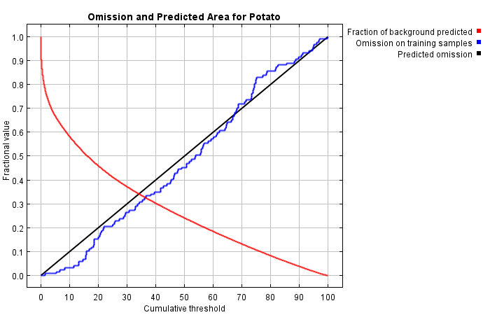

The next picture is the receiver operating characteristic (ROC) curve for the same data. Note that the specificity is defined using predicted area, rather than true commission. This implies that the maximum achievable AUC is less than 1. If test data is drawn from the Maxent distribution itself, then the maximum possible test AUC would be 0.722 rather than 1; in practice the test AUC may exceed this bound.

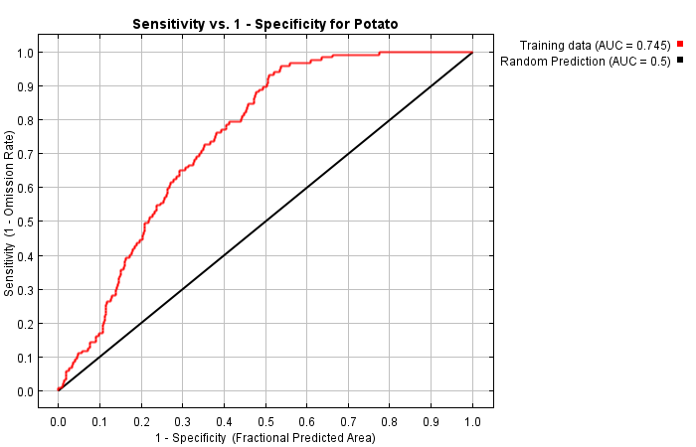

🡨Thank You🡪